**TEST2**

**Find as many unreasonable points as you can and list them all:**

1. There is no options to minimize and close the window:

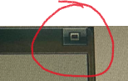

1. There is no need to show the Type, it’s already the same as Name select input:

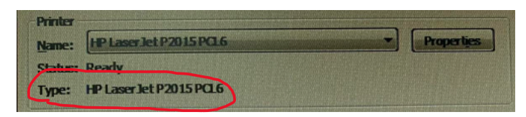

1. There is Check box without any labels:

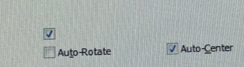

1. The layout of this legend is messy:

* Inputs are not aligned
* Sizes is not fit with contents
* Unnecessary spaces

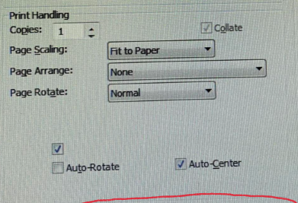

1. Wrong-positioned divider:



1. The Units are not matched, and there is no options to change units



1. Should add Paper size description like A4, Letter, .etc
2. The radio group should only have one options selected:

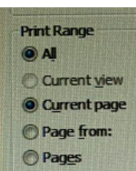

1. Select input should not be used here, should replace with number input, also unnecessary input shown 1-195,can be deleted

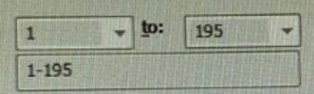

1. No options to zoom out:



1. No options to go to last:



1. Size is not matched:

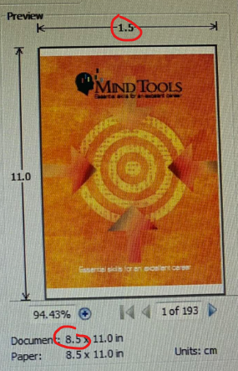

1. Button position is not right:

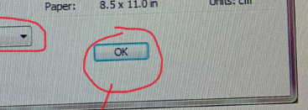

1. Doubled checkboxes:

